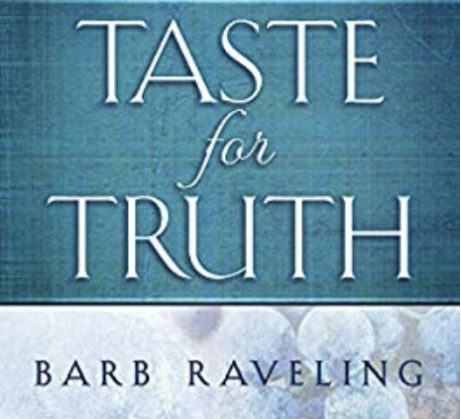
A 30 Day Weight Loss Bible Study ~ The Taste for Truth
1  RENEWING MY MIND IS THE KEY TO MY VICTORY | 2  LIFE IS BETTER  WITH  BOUNDARIES | 3  IT WON’T BE  EASIER  ‘TOMORROW’ | 4  NOT EVEN  ONE BITE OUTSIDE MY BOUNDARIES | 5  EMBRACE  YOUR  BOUNDARIES | 6  AN EVENT WILL ALWAYS BE AROUND THE CORNER
7  IS MORE  REALLY  BETTER | 8  GOD USES DISCIPLINE  TO GROW FRUITFULNESS  IN US | 9  AM I TRYING TO JUSTIFY BREAKING MY BOUNDARIES | 10  I WILL NOT  EAT  TO CONSOLE MYSELF | 11  MY WORTH IS NOT  DETERMINED BY  A NUMBER ON  THE SCALE | 12  IS GOD  ENOUGH TO  SATISFY  YOU
13  AM I EATING BECAUSE THE WEIGHT ISN’T COMING OFF AS I WANT IT TO | 14  TAKE OFF THE LIES AND  PUT ON TRUTH | 15  NOTHING IS BETTER THAN SWEET FELLOWSHIP WITH GOD | 16  I’M BREAKING FREE FROM A  ‘FAILURE EATING’ MENTALITY | 17  THE BATTLE ISN’T HOPELESS AS LONG AS I KEEP FIGHTING  THE LIES | 18  FOOD CANNOT  SOLVE  MY PROBLEMS
19  ONLY HE  CAN  TRULY  SATISFY | 20  HAVE YOU BEEN DILIGENT ABOUT RENEWING  YOUR MIND | 21  IF WE GET RID OF THE EMOTION,  WE GET RID OF THE DESIRE TO EAT | 22  RELY ON GOD  FOR STRENGTH  AND HOPE | 23  SPIRITUAL WARFARE IS ESSENTIAL IF WE WANT TO BE VICTORIOUS | 24  TAKE EVRY THOUGHT CAPTIVE TO THE OBEDIENCE OF CHRIST
25  PRAYING THE SCRIPTURE IS A POWERFUL TOOL TO RENEW OUR MINDS | 26  PRACTICE MINDFUL EATING BY FOCUSING ON THE TASTE OF YOUR FOOD | 27  THE TRUTH WILL  SET US FREE,  BUT ONLY IF WE PURSUE IT | 28  OBSESSION  LEADS TO CONDEMNATION | 29  GOD USES  TRIALS TO HELP US GROW | 30  BOUNDARIES ARE FOR MY PROTECTION
WELLNESS REVOLUTION

